|  |  |  |
| --- | --- | --- |
| **#NO** | **Students Names** | **Topics** |
| **Group 1** | Hamza Alsurakhi  Haitham kamal alrawi  Suhib Alhanafi  رانيا عماد محمود شلبايه  Mohammad Al-Zaro | * Session Storage in JS  JSONAsynchronous JS |
| **Group 2** | عمار جمال  zahera abdalrahman saleh alakash  Zaid Osama Ahmad Taha  حمزة خلف المجالي  مهدي طه جودت ابراهيم | * Local Storage in Js  JSONAsynchronous JS |
| **Group 3** | معاذ جوابره  اسامة محمد اعمر  حازم كمال محمد سلامه  مؤمن نعيم صافي  جعفر عبد المجيد مفلح الوحش | * Session Storage in JS  JSONAsynchronous JS |
| **Group 4** | Yousef Al deeb  Kareem Al_Skafi  Aya khaldoun Odeh Al Odat  عبدالله ابوعرب  Ayman | * Local Storage in Js  JSONAsynchronous JS |
| **Group 5** | Abedelhameed Alshorafa  معاذ محمد عبدالرحيم  اية التويمي  Baker Sabbagh  Baseel shanableh | * Session Storage in JS  JSONAsynchronous JS |
| **Group 6** | عبدالرحمن محمد عوده  Shoroq Salameh  حلا علي التميمي  Saif Alden Ali Mohammed Mehdawi | * Local Storage in Js  JSONAsynchronous JS |

Note: It is necessary to clarify the difference between local storage and session storage, such as:

* Scope of Data
* Lifetime:
* Storage Size and so on …

Required method:

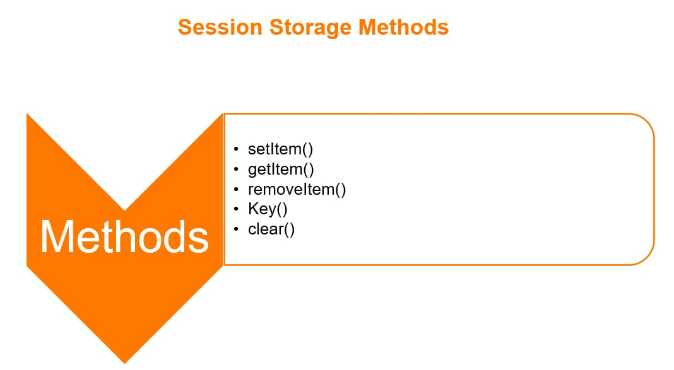

Required method:

